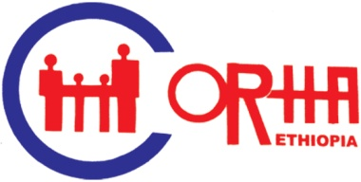
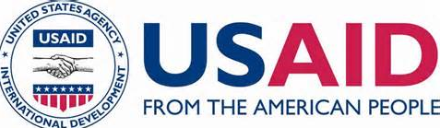

Terms of Reference
Training on Knowledge Management for Organizational Effectiveness

- Background

The Consortium of Reproductive Health Associations (CORHA) is an organizational expression of the determination of NGOs committed to the provision of comprehensive, integrated and sustainable sexual and reproductive health information and services in Ethiopia. The organization is Reproductive Health focused Consortium which has been functioning effectively in creating platforms for policy discussion and dialogue, coordinating members’ activities and representing its members and capacity building.

CORHA is awarded to implement the Enhancing the Capacity of NGOs for Quality FP/MCH Services project through direct USAID financial support. The project is expected to improve the capacity of CORHA member organizations to enable them provide quality FP/MCH services in their target areas. It mainly focuses on strengthening technical, organizational and institutional capacity building of CORHA member organizations. Under this project, CORHA intends to strengthen the competencies of 20 direct beneficiaries of CORHA member organizations to deliver quality RH information and services.

According to the Organizational Capacity Assessment report, most of the direct project beneficiary organizations suffer from staff turnover, lack of institutional memory, loss of hard and electronic documents, and poor knowledge application. Cognizant of the fact that success and institutional development depends on harnessing Knowledge Management (KM) to improve programs, services, and increase organizational sustainability, CORHA would like to organize five days Knowledge Management training to direct project beneficiary organizations.

II. Objectives

General Objective:
The principal aim of the training will be to enhance networking of information and knowledge with key stakeholders, including governments, CORHA, Other CORHA member organizations and development partner organizations involved in SRHR activities.

Specific objectives:
- Perform KM using proven tips/tools anyone can use
- Build Collaborative Environments; better communication, spark innovation
- Transform their organization into a rapid learning environment
- Develop innovative ways to motivate their staff with quick wins
- Create the KM Vision for their organization, including a solid strategy to get there
- Initiate with their peers successful Communities of Practice
- Discover usable, real world KM principles and keys to success
III. Major Activities of the Consultant

The consultant will be responsible for undertaking the following training tasks:
- Prepare the course contents/topics with its time schedule to be covered in the training
- Gives a clear explanation of the course topics with specific examples, focusing on Reproductive Health issues
- Prepare and distribute training materials (course notes)
- Prepare PowerPoint presentations
- Facilitates group works/discussions
- Supervise and guide the trainees during their group works
- Work in close collaboration with CORHA
- Prepare and submit the training report to CORHA

Responsibilities of CORHA

- Coordinate overall process of the training
- fulfill the necessary inputs and logistics for the training
- Pay consultancy fee to the consultant as per the contractual agreements signed
Duration of the assignment
The duration of the assignment is for ten days including the preparation of training materials, provision of 5 days training and report writing after training.

Required qualification, skill and experience
The consultant should meet the following qualifications and skills:
- The task requires at least two trainers with a minimum of M.A/MSc.) Degree or equivalent in Organizational Management, Economics, Management or other relevant discipline.
- Familiarity and practical experience in the area, particularly in developing training manual
- Experienced in conducting training on Project Cycle Management
- Experienced in working with capacity development of NGOs

V. Duration of the assignment
The duration of the assignment is for ten days including the preparation of training materials, provision of 5 days training and report writing after training.

VI. Terms of payment
The payment will be effected upon the completion of the training and submission of a comprehensive report to CORHA.
VII. TAXTION:
Taxation will be as per the law of the land. The Consultant shall be liable for all taxes levied by the Government.
VIII. TERMINATION
If the Consultant is unable to complete the task for any reason, CORHA shall have the option to terminate this agreement unilaterally on business. The Consultant’s non-performance of the duties described in the TOR will constitute a breach of this agreement and will be a court case and all costs related to this case will be covered by the consultant. However, the Consultant will not be responsible for any delay or cancelation caused by the client.
Application Procedures
Interested consultants/consultancy firms satisfying the required qualification and skills are invited to submit hard copies of their application/proposal with a cover letter to the CORHA office, located at Kebena area, near to OiLibiya, Oromiya Forest and Wildlife Development Enterprise Building, 1st Floor before 14 May 2015.
For further information, please call to CORHA office at 0111260320 or 0118592642
Note
Please note that only selected consulting firms/independent consultants will be contacted

